Problem 1.

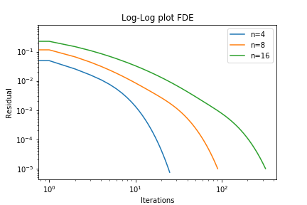

|  |  |  |  |
| --- | --- | --- | --- |
| n | Error | # of Iterations | Error Ratio |
| 4 | 0.0024391 | 27 |  |
| 8 | 0.000678665 | 92 | ~ 3.6 |
| 16 | 0.000150453 | 325 | ~4.5 |

As n increase or h decrease the error reduces. Maybe because as the grid become more denser the approximation by FDE become more accurate. The error decrease by a factor of 4 as we divide the h by 2.

Problem 2

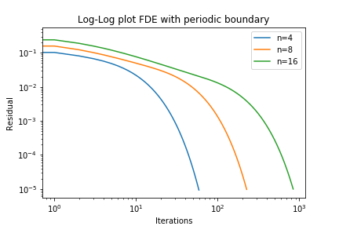

|  |  |
| --- | --- |
| n | # of Iterations |
| 4 | 61 |
| 8 | 229 |
| 16 | 845 |

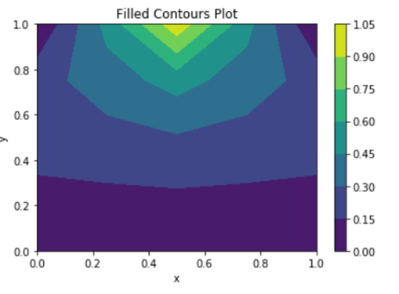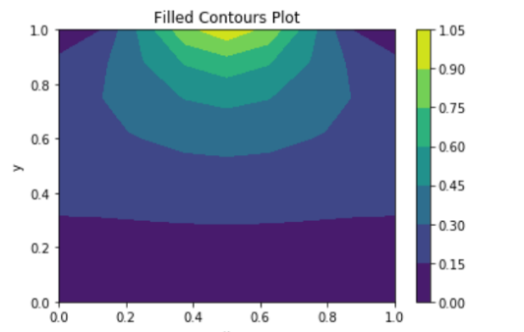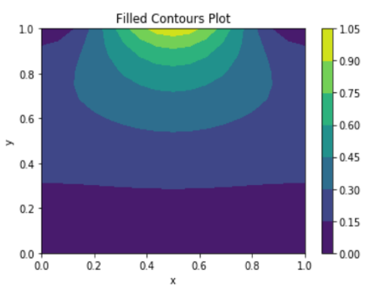

N = 4 n = 8 n = 16